**953232**

**Object oriented analysis and design**

**COFFEE SHOP**

**Presented**

Mr. Prompong Sugunnasil

**By**

5821150

582115026 Mr.

582115037 Mr. Phornthep Chooleat

582115039 Mr.

**BACHELOR OF SCIENCE**

**SOFTWARE ENGINEERING PROGRAM**

**COLLEGE OF ARTS, MEDIA AND**

**TECHNOLOGY**

**CHIANG MAI UNIVERSITY**

**APRIL 2017**

**Use Case Diagram**

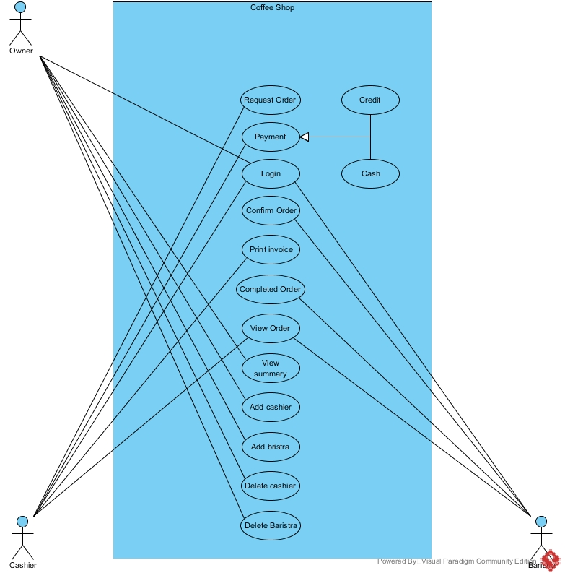

**Use Case 1: Request Order**

|  |  |  |  |  |
| --- | --- | --- | --- | --- |
| Use Case ID | US-001 | | | |
| Use Case Name | Request order. | | | |
| Created By | Phornthep Chooleat | | Last Update By | Phornthep Chooleat |
| Date Created | 22/04/2017 | | Last Revision Date | 22/04/2017 |
| Actors | Cashier. | | | |
| Description | Cashier take order from customer and request to barista. | | | |
| Trigger | Customer want to order the goods. | | | |
| Preconditions | Cashier mush to logged in the system. | | | |
| Use Case Input Specification | | | | |
| Input | type | Constraint | | Example |
| orderName | String | The character more than 3 characters and less than 500 characters. | | Milk shake with caramel and whipping cream. |
| Post conditions | Send order information to barista. | | | |
| Normal Flows | User | | System | |
|  | 1. User select the Request order in main menu. 2. User input the order from customer to the system. | | 1. System provide Order requesting to the user. 2. System print order id to user. 3. System send the data to barista. | |
| Alternative Flow | - | | | |
| Exception Flow | - | | | |
| Assumption | 1. User understand English. 2. User understand the customer order. | | | |

**Use case 2: Payment**

|  |  |  |  |  |
| --- | --- | --- | --- | --- |
| Use Case ID | US-002 | | | |
| Use Case Name | Payment | | | |
| Created By | Phornthep Chooleat | | Last Update By |  |
| Date Created | 22/04/2017 | | Last Revision Date |  |
| Actors | Cashier. | | | |
| Description | Customer request cashier to pay a bill. | | | |
| Trigger | User select Payment button. | | | |
| Preconditions | 1. User mush logged in into the system. 2. Customer want to pat a bill. | | | |
| Use Case Input Specification | | | | |
| Input | type | Constraint | | Example |
| orderId | int | Numerical of 3 digit. | | 001 |
| amountOfMoney | double | Numerical more than 1 digit and less than | |  |
| Post conditions |  | | | |
| Normal Flows | User | | System | |
|  | 1. User select payment button in the menu. 2. User in put order id to the system. 3. User select confirm payment. 4. User select payment method as cash. 5. User input amount of money received from customer. 6. User select confirm. 7. User select print invoice. | | 1. System request order id from user. 2. System check the order id that received from user. 3. System show amount of value to the user. 4. Provide confirm payment page to user. 5. System request type of payment (credit, cash) from user. 6. System request amount from user. 7. System check the input. 8. System calculate the change. 9. System show amount of change to user. 10. System open the money tray. 11. System provide receive money page to user. 12. System ask the user to close the money tray. 13. System close the money tray. 14. System record the transaction to the data base. 15. System ask user do they need to print the invoice. 16. System provide print invoice page to user. | |
| Alternative Flow | 1. In the activity 4 of Normal flow, if user input wrong order id system will provide “Wrong id or not have this id in the system” Message to user and system back to the activity 2 in Normal flow. 2. In the activity 7 of Normal flow, if user do not confirm system will provide the main menu page to user. 3. In the activity 12 of Normal flow, if user input incorrect input system will provide “Wrong input please input it again.” Message to user and system back to the activity 10 in Normal flow. 4. In the activity 18 of Normal flow, if user do not confirm after 3-minute system will provide “Automatically close money tray because money tray had opened more than 3-minute.” Message to user and system ask user to login to open the money again. 5. In the activity 20 of Normal flow, if user do not select invoice system will provide the main menu page to user. 6. In the activity 9 of Normal flow, if user select payment method as credit system will provide credit payment to user.    1. System request credit card from user.    2. User input the credit card to credit card machine.    3. System Check the permission from the bank.    4. System subtract amount of bill in the credit card.    5. System print receipt to the user.    6. System do the activity 19 in the Normal flow. 7. In the activity 6.3. of Alternative flow, if the bank does not allow system to do the payment system provide “Can’t pay by credit card please use another payment method.” Message to user and back to the activity 7 in the Normal flow. | | | |
| Exception Flow | - | | | |
| Assumption | 1. User understand English. 2. Cashier machine have change for user. | | | |